ATM TRANSACTION
SIMULATOR
A Java-Based Mini Project Report

Submitted as part of the Java Programming Course
Modules Covered: 1–6

Student Name: LAASYA SUREPALLI
Roll Number: 2620030160
Department / Section: CSE/SECTION-12
Faculty Name: MS. SWATHI

Project Abstract

The ATM Transaction Simulator is a console-based Java application that models the basic operations performed at an Automated Teller Machine (ATM). It allows a user to enter a PIN, check an account balance, deposit money, withdraw money, and view a transaction history. The program validates user input, checks available balance before withdrawals, and records completed transactions. It is designed as an educational project to demonstrate how Java programming concepts can be combined to solve a practical problem.
The project connects computational thinking and algorithm design with Java foundations, control-flow statements, methods, arrays, object-oriented programming, exception handling, strings, file input/output, collections, and streams. For classroom use, the simulator uses sample data and is not connected to a real bank or payment network.

Project Objectives

- Design an ATM workflow using a clear algorithm and a simple menu-driven interface.
- Apply Java primitive data types, variables, constants, operators, type conversion, and console input/output.
- Use conditional statements and loops to validate a PIN, select operations, and repeat transactions.
- Organize the program into reusable methods with parameters and return values.
- Use arrays and two-dimensional arrays to store and summarize transaction information.
- Model an account and ATM operations using classes, objects, constructors, encapsulation, and static constants.
- Handle invalid input and runtime problems safely with exception handling.
- Use strings, collections, sorting/searching algorithms, and file handling to maintain transaction records.
- Explore lambdas and streams to filter, count, and summarize transactions.
- Build confidence in testing, debugging, modular design, and documentation.

Advantages

- Provides a simple and understandable simulation of common ATM operations.
- Improves understanding of Java concepts through one integrated project.
- Uses methods and classes to make code easier to read, test, and maintain.
- Validates inputs and prevents invalid deposits, withdrawals, and insufficient-balance transactions.
- Can keep a transaction history in memory and, when implemented, in a text file.
- Can generate useful summaries such as transaction counts and total deposits or withdrawals.
- Can be expanded with a graphical interface, multiple accounts, or a database in future versions.

4. Implementation Details

4.1 System Overview
The user interacts with a menu displayed in the console. After PIN validation, the user selects an operation. The program validates the amount, performs the operation when the rules are satisfied, updates the balance, and records the result. The user can repeat operations until choosing Exit.

4.2 Basic Algorithm
- Start the application and initialize a sample account, PIN, balance, and transaction store.
- Read the PIN using Scanner and compare it with the stored sample PIN.
- If the PIN is invalid, display an error and allow a limited number of attempts or end the session.
- Display the ATM menu: Check Balance, Deposit, Withdraw, Transaction History, and Exit.
- Read the selected option and use switch-case to route the request.
- For deposits and withdrawals, validate that the amount is numeric and positive.
- For withdrawals, verify that the requested amount does not exceed the available balance.
- Update the balance and record successful transactions; display a suitable message.
- Repeat the menu until Exit is selected, then close resources and end the program.

4.3 Mapping to the Java Modules
Module | Concepts | Application in the Project
1. Java Foundations | Algorithm, flowchart, data types, variables, constants, identifiers, literals, operators, typecasting, precedence, Scanner, formatted output | Represent balance and amounts, validate input, calculate balances, and display menus and receipts.
2. Control Flow | if/else, nested conditions, if-else-if, switch, break, while, do-while, for, continue, nested loops | Validate PIN and amounts, select menu actions, repeat the session, and iterate over records.
3. Methods, Recursion & Arrays | Methods, parameters, return values, overloading, recursion, for-each, 1D and 2D arrays | Separate deposit/withdraw methods, search transaction IDs, total transactions, and build a summary matrix.
4. OOP & Exceptions | Classes, objects, fields, constructors, this, encapsulation, static/final, toString, inheritance, interfaces, overriding, try/catch/finally, throw/throws | Represent accounts and transactions as objects, protect balance fields, and handle invalid operations or file errors.
5. Strings, Algorithms & File I/O | String operations, equals vs ==, StringBuilder/Buffer, split/join, validation, sorting/searching, Comparable/Comparator, Files/Path, readers/writers, try-with-resources | Format receipts, parse saved records, sort/search transaction data, and persist history in a text file.
6. Collections & Streams | List, Set, Map, ArrayList, HashMap, HashSet, generics, iterators, lambdas, functional interfaces, streams and collectors | Store transactions dynamically, prevent duplicate IDs, look up records, and produce summaries using filter, map, count, and collect.

4.4 File Handling and Reports
A text file such as transactions.txt can be used to save transaction records. java.nio.file.Path and Files can read or append records, while try-with-resources ensures that file resources are closed automatically. Each record should use a consistent format, such as transactionId, type, amount, timestamp. When loading data, split and validate each line, skip or report malformed records, and handle missing files gracefully. Collections and streams can then filter transactions by type, sort them by amount or time, count records, and collect a simple report.

4.5 Testing Plan
Test Case | Input / Action | Expected Result
Valid PIN | Enter the configured sample PIN | Menu is displayed.
Invalid PIN | Enter an incorrect PIN | Access is denied or another attempt is requested.
Balance enquiry | Choose Check Balance | Current sample balance is shown.
Valid deposit | Enter a positive amount | Balance increases and transaction is recorded.
Insufficient funds | Withdraw more than the balance | Withdrawal is rejected; balance is unchanged.
Invalid amount | Enter zero, a negative value, or non-numeric text | Input is rejected and handled safely.
Transaction history | Choose Transaction History | Recorded transactions are displayed.
Exit | Choose Exit | A closing message is displayed and the session ends.

Output Screenshots

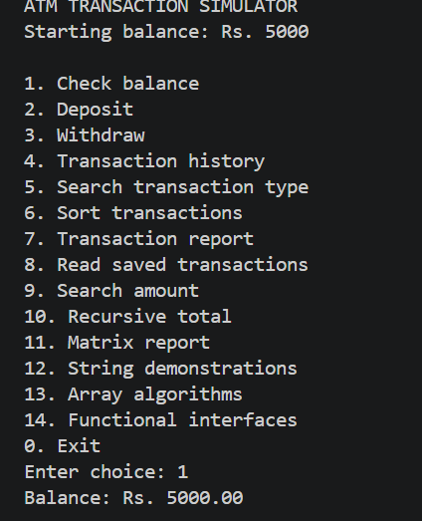

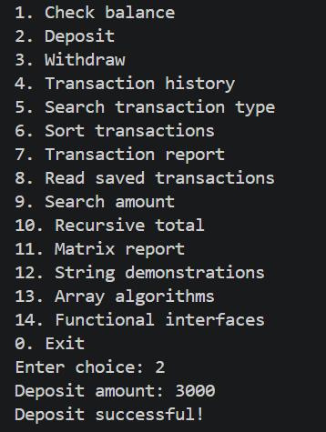

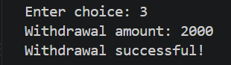

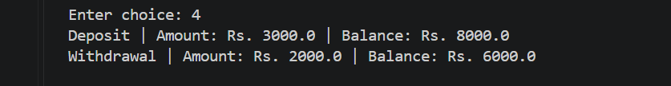

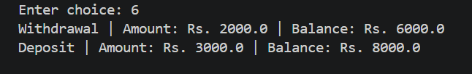

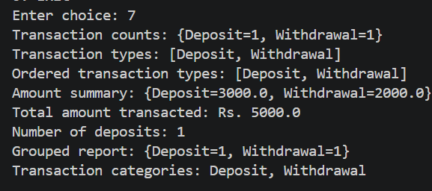

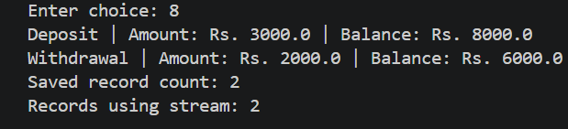

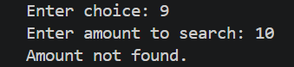

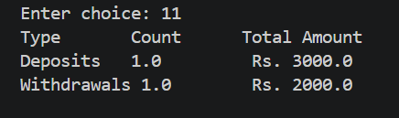

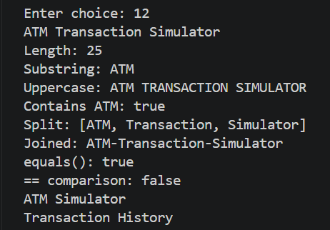

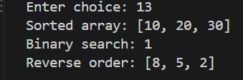

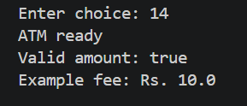

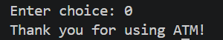

5.Conclusion

The ATM Transaction Simulator demonstrates how core Java concepts can be applied to a practical, menu-driven application. It combines input/output, operators, conditional statements, loops, methods, arrays, object-oriented design, exception handling, strings, collections, and file operations. The project also highlights the importance of validation, modularity, and reliable transaction records. Although it is an educational simulation rather than a real banking system, it provides a strong foundation for building more advanced Java applications.

Future Work

- Add a graphical user interface using JavaFX or Swing.
- Support multiple users and accounts with secure, hashed PIN storage rather than plain-text credentials.
- Connect to a database using JDBC for persistent account and transaction data.
- Add fund transfers, mini statements, daily withdrawal limits, and configurable transaction fees.
- Use interfaces and service classes to separate user interface, business logic, and storage.
- Improve audit logs and add role-based access, secure session handling, and stronger validation.
- Add unit tests and automated test cases for deposits, withdrawals, PIN checks, and file parsing.
- Use streams and collectors to create monthly summaries, transaction counts, and account activity reports.
- Handle simultaneous sessions and transaction consistency if the application is expanded into a multi-user system.

